**CSS Selector**

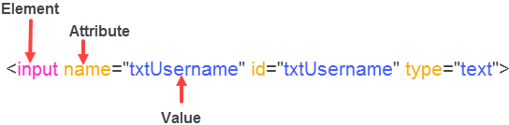

1. **Locating elements by ID:**

In CSS **#** sign is used for locating the elements by value of **ID**

Syntax: elementName**#**valueofID

**#**valueofID

http://pragmatictestlabs.com/wp-content/uploads/2018/05/6.png

Example:

input**#**txtUserName

**#**txtUserName

1. **Locating elements by Class:**

Syntax: elementName**.**className

**.**className

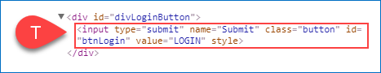

Example:

input.button

**.**button

1. **Locating elements with a known value(s):**

Syntax: [Attribute=’Value’]

http://pragmatictestlabs.com/wp-content/uploads/2018/05/5.png

Example:

[name=’tstUserName’]

[id=’txtUserName’]

[type=’text’] ----- > Valid CSS but not recommended

1. **Locating elements with known element and Attributes:**

Syntax: elementName[Attribute=’Value’]

http://pragmatictestlabs.com/wp-content/uploads/2018/05/6.png

Example:

Input[name=’txtUserName’]

Input[id=’txtUserName’]

Input[type=’text’]

1. **Locating elements by multiple classes:**

Syntax: ElementName.className1.className2….classNameN

**.**className1.className2…classNameN

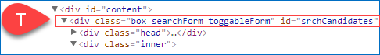

Example:

div.box.searchForm.toggableForm

.box.search.toggableForm

1. **Locating elements by class name and attribute:**

Syntax: elemantName.className[Attribute=’value’]

.className[Attribute=’value’]



Example:

input.button[name=’Submit’]

.button[name=’Submit’]

1. **Locating elements by prefix of the attribute value ( starts-with):**

Syntax : elementName[Attribute^=’prefix-of-the-value’]

[Attribute^=’prefix-of-the-value’]

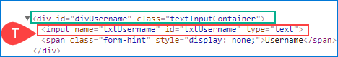

Example:

Input[name=’txtUser’]

[name=’txtUser’]

1. **Locating elements by suffix of the attribute value ( ends-with):**

Syntax: elementName[Attribute$=’suffix-of-the-value’]

[Attribute$=’suffix-of-the-value’]



Example:

input[name$=’name’]

[name$=’name’]

1. **Locating elements containing part of the attribute value:**

Syntax: elementName[Attribute*=’any-part-of-the-value’]



Example:

Input[name=’User’]

1. **Locating elements by part of the Inner Text:**

Syntax: elementName:contains(‘part-of-the-text’)

http://pragmatictestlabs.com/wp-content/uploads/2018/05/22.png

Example:

a:contains(‘Pragmatic’)

1. **Locating elements by attributes ignoring the case semsitivity:**

Syntax: elementName[Attribute=’value’,i]

[Attribute=’value’,i]

http://pragmatictestlabs.com/wp-content/uploads/2018/05/23.png

Example:

input[id=’txtusername’,i]

[id=’txtUSERNAME’,I]

1. **Locating elements by multiple attributes:**

Syntax: elementName[Attribute1=’value1’][Attribute2=’value2’][Attribute3=’values’]

[Attribute1=’value1’][Attribute2=’value2’][Attribute3=’values’]

http://pragmatictestlabs.com/wp-content/uploads/2018/05/11.png

Example:

Input[name=’txtUserName’][id=’txtUserName’][type=’text’]

1. **Locating child elements by element name:**

Syntax: #CSSofParent>elementName

http://pragmatictestlabs.com/wp-content/uploads/2018/05/11.png

Example:

#divUsername>input

1. **Locating descendant elements by an element name:**

Syntax: CSSofParent<space>ElementName

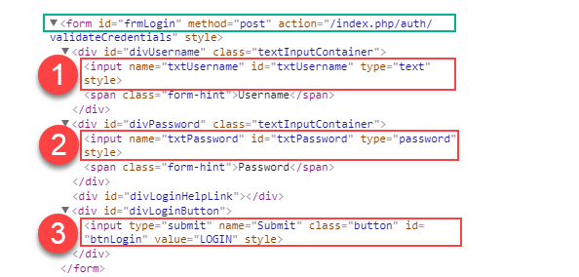

Example:

form input

1. **Locating Nth child elements by an element name:**

Syntas CSSofParentElementName<space>ElementName:nth-of-type(N)

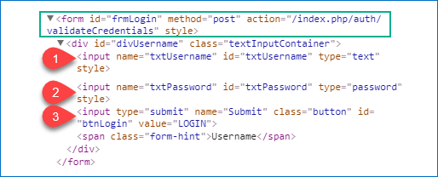

Example:

form input:nth-of-type(1) selects the first candidate

form input:nth-of-type(3) selects the third candidate

1. **Locating first child element and last child element by element name:**

Syntax: CSSofParentElementName<space>ElementName:first-child ------ for first child

CSSofParentElementName>elementName:first-child

Syntax: CSSofParentElementName<space>ElementName:last-child ------ for last child

CSSofParentElementName>elementName:last-child



Examples

form input:first-child or form>div>input: first-child --- for first child

form input:last-child or form>div>input:last-child --- for last child

1. **Locating next sibling of a known element:**

Syntax: CSS-of-context-element + elementName

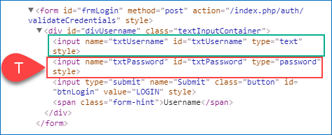

Example:

#txtUsername + input

1. **Locating following sibling of a known element:**

Syntax: CSS-of-context-element-elementName

Example:

#txtUsername-input